MICHAEL GRAVES
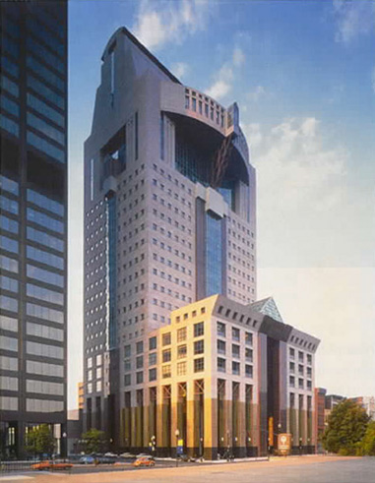  Humana Building in Louisville, Kentucky | 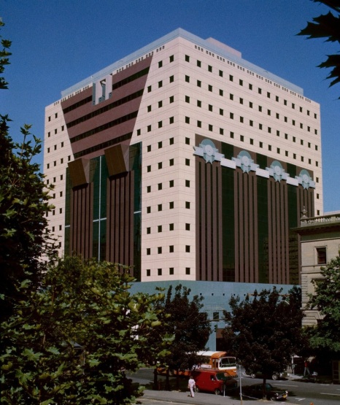  The Portland Building in Oregon_1982 | 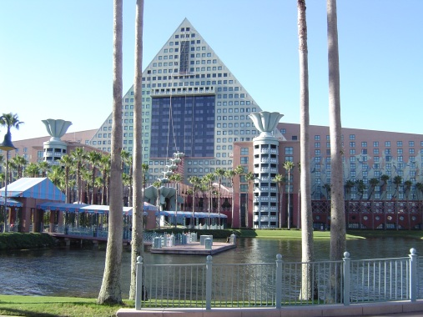  The Walt Disney World Dolphin Resort in Orlando, Florida
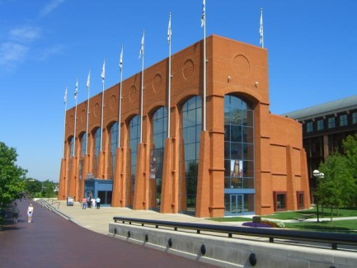  NCAA Hall of Champions in Indianapolis, Indiana. | 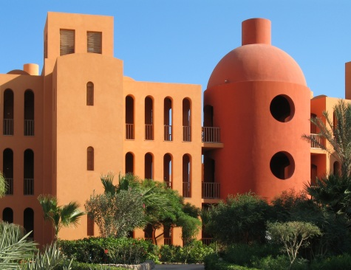  Steigenberger Hotel in El Gouna, Egypt, in association with Ahmed Hamdy | 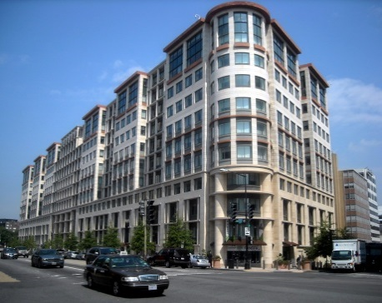  The International Finance Corporation Building in Washington, D.C.

Graves and his firm have earned critical acclaim for a wide variety of commercial and residential buildings and interior design, although some occupants of the buildings object to the confined views caused by signature features such as small or circular windows and squat columns.

Robert A.M. Stern

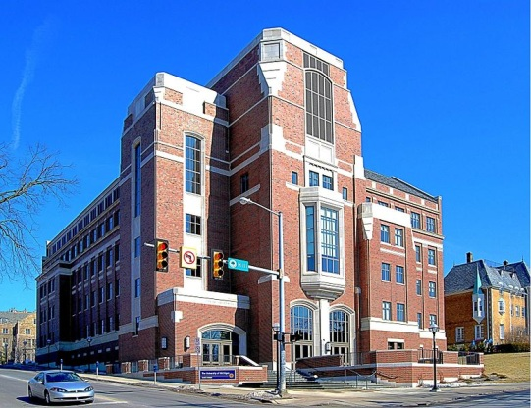Gerald R. Ford School of Public Policy | 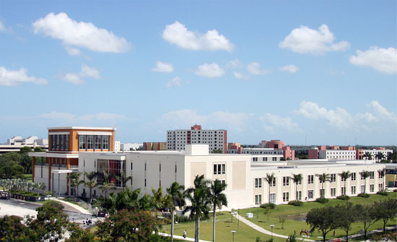  Rafael Diaz-Balart Hall, home of the FIU College of Law in Miami, Florida. | 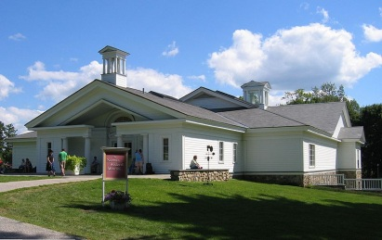  Norman Rockwell Museum.
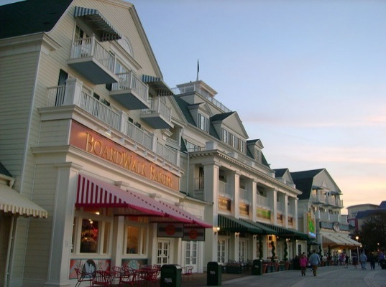  Disney's BoardWalk Resort  Hotel and entertainment complex at the Walt Disney World Resort | 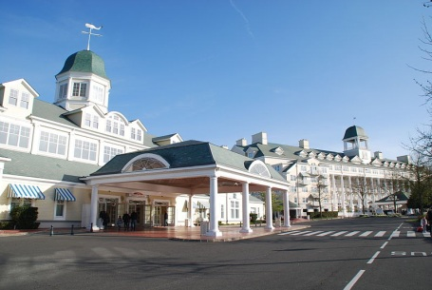  Disney's Newport Bay Club | 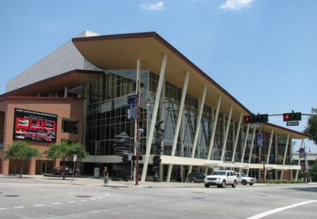  Hobby Center for the Performing Arts

Robert A.M. Stern is a practicing American architect, teacher, and writer. He is a Fellow of the American Institute of Architects. He personally directs the design of each of the firm's projects. He was previously Professor of Architecture and Director of the Historic Preservation (наследия) Program at the Graduate School of Architecture, Planning, and Preservation (консерватором и хранителем) at Columbia University.
Mr. Stern was representative of Modern Classicism direction the design of projects.
Mr. Stern's work has been exhibited at numerous galleries and universities and is in the permanent collections of the Museum of Modern Art.

Philip Cortelyou Johnson
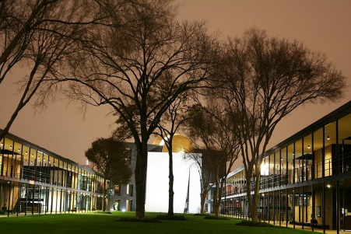  Chapel of St. Basil on the Academic Mall at the University of St. Thomas in Houston, Texas. | 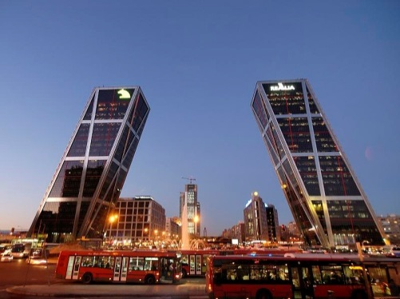  Puerta de Europa in Madrid | 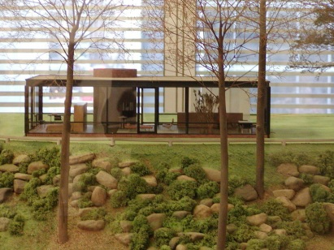  A model of the Glass House on display at the Museum of Modern Art in New York City
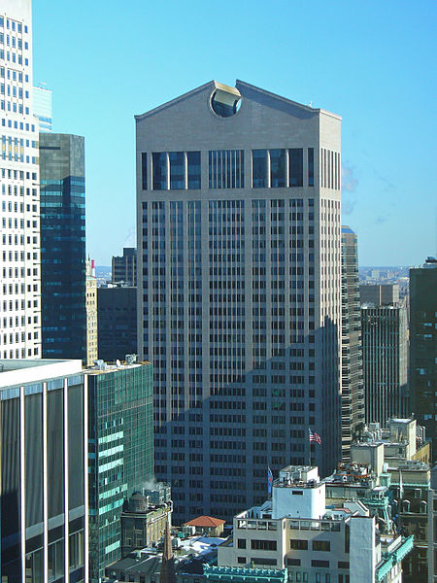  The postmodern AT&T Building, now the Sony Building | 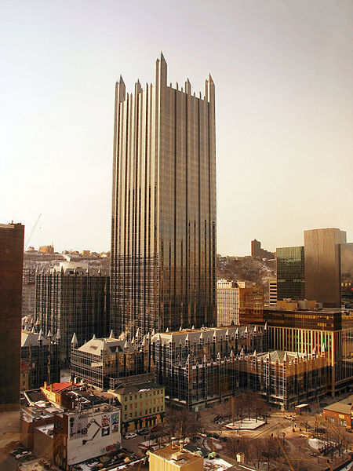  PPG Place in Pittsburgh, Pennsylvania, in 2007. | 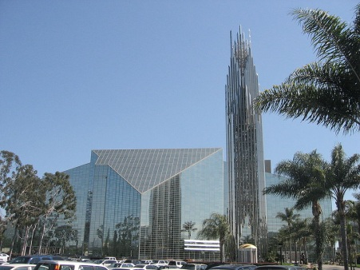  The Crystal Cathedral, Garden Grove, California in 2007.
He focused on history and philosophy, particularly the work of the Pre-Socratic philosophers.
Johnson returned from Germany as a proselytizer for the new architecture. Touring Europe more comprehensively with his friends Alfred H. Barr, Henry- Hitchcock to examine firsthand recent trends in architecture, the assembled their discoveries as the landmark show "The International Style " at the Museum of Modern Art, in 1932. The show was profoundly influential and is seen as the introduction of modern architecture to the American public. Johnson's early influence as a practicing architect was his use of glass; his masterpiece was the Glass House. Johnson defied every precept of the modernist aesthetic: historical pattern had been effectively outlawed among architects. Building as the first Postmodernist statement, necessary in the context of modernism's aesthetic cul-de-sac.

